|  |  |
| --- | --- |
| Your GBS Score | Your Certification |
| **77%** | **Merit**    All modules >= 40% At least 5 >= 75% |

You achieved a Merit and can now start thinking about how to strengthen your skills for even higher performance. Overall, your results are commendable, with your average GBS score falling above the Cohort Average. Your best scores were Time Management and Effective Meetings. How to Say No and Critical Thinking are areas where further focus is needed. We hope you use this feedback as an opportunity to continue investing in yourself and achieve even greater success professionally

.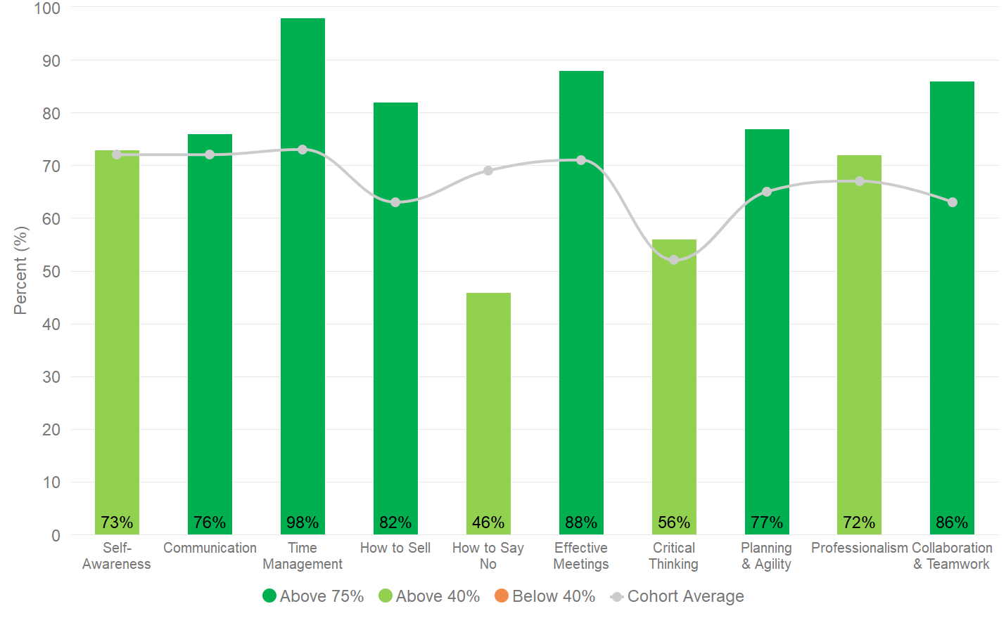

|  |
| --- |
| Chart 1: This chart illustrates your score in each module as well as the average score achieved by your Cohort. Scores are a total of multiple choice and open text questions within GBS. |

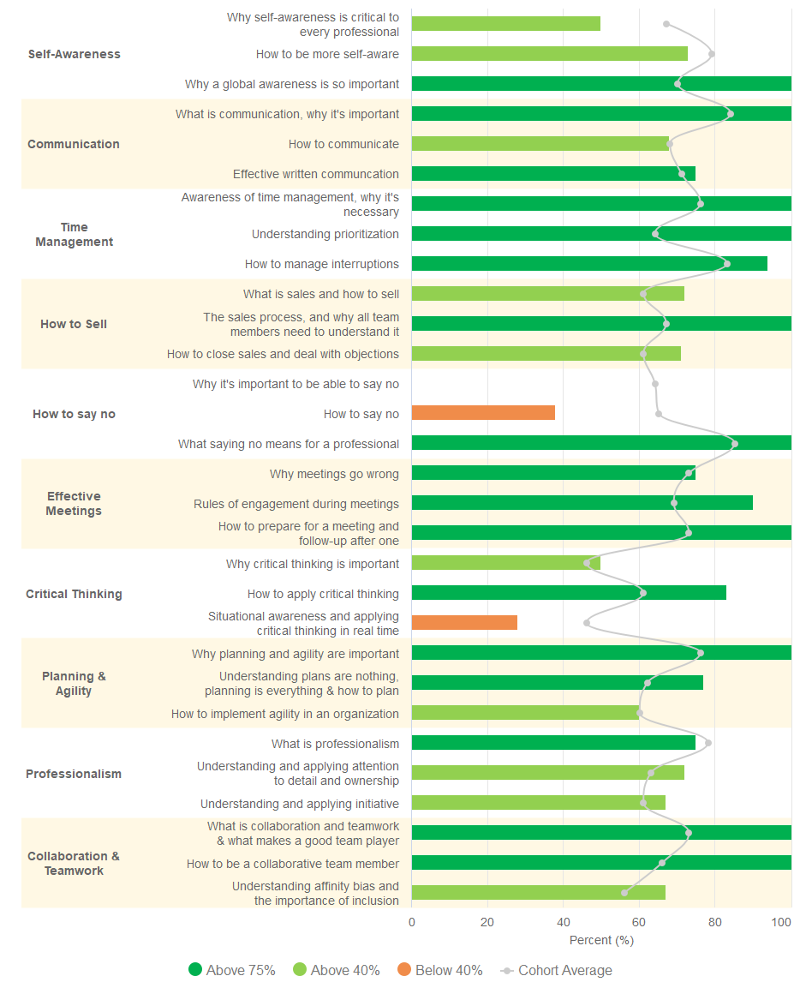

|  |
| --- |
| Chart 2: This chart provides insight into your relative strengths and weaknesses within a topic. Use it to identify concepts that you are strong in and areas you need to work on. |

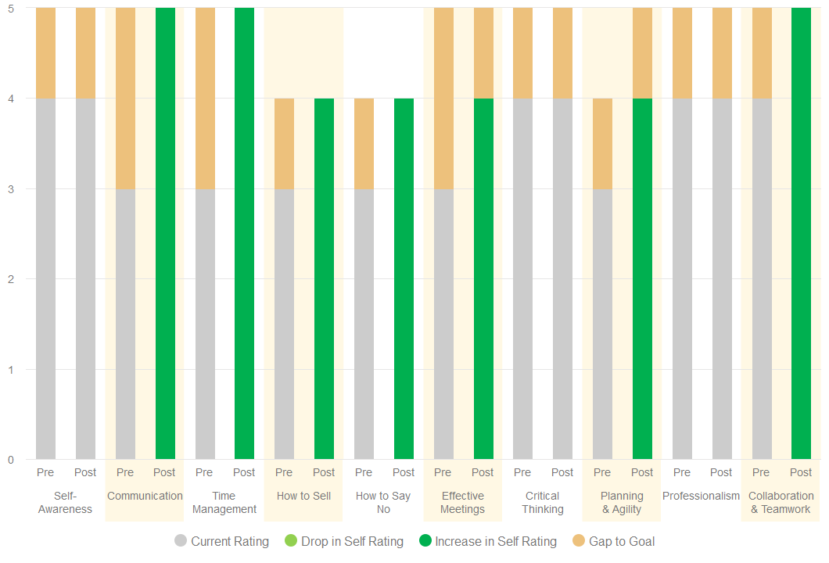

|  |
| --- |
| Chart 3: This chart compiles data from the questionnaires at pre- & post-completion and tracks how your self-rating of current skills and the goal you want to achieve changed as you progressed through the course. It’s designed to help you reflect on current skill levels, goals, and to better understand what gaps need to be covered.   * Rating your current skill levels progressively higher (shown in the darker green where applicable) means you believe you’ve improved. If this is true - aim higher! * If the trend shows you rate your current skill level lower (shown in lighter green where applicable), this can indicate improving self-awareness as you are being more realistic and aspiring in your goals. * Gap-to-goal is the difference between the skill level you’d like to be at and current skill level. You should always be learning and improving your skills and so, having a gap of 0 is undesirable! * Rating your current skill level 5 implies you don’t believe any improvement is needed – or possible! * If you are rating yourself highly, but the scores in the modules show weakness in the same skill – it’s time to seek feedback to see if you have a blind spot that needs addressing. |

RECOMMENDATIONS

With the Global Business Skills course completed, it’s time to start implementing new tools, knowledge and skills to help you be more successful - professionally and personally. You've covered a lot of ground - what new habits and behaviours can you cultivate to become more effective? We have some personal recommendations for you to get started on.

* Saying 'Yes' to everybody and everything leads to the Cycle of Chaos and, ultimately, failure! Being able to say NO when it is the correct answer is a sign of strength and professionalism. Practice direct open communication as often as you can, and this will lead to operational effectiveness.
* Critical thinking relies on situational awareness, which involves knowing what to observe, consider and act upon in your surrounding environment. Use the 5 Questions tool to master situational awareness, and the 4 Steps to Critical Thinking to arrive at decisions that are well thought out. Constantly seek opportunities where you can challenge assumptions and apply reason in your everyday work life.
* The level of initiative a person brings to their role defines quality of performance. According to the 5 Levels of Initiative concept, every professional should have the goal of being at Level 4 at least. This level includes independently identifying a problem at work, investigating causes, offering possible solutions and recommending which would be best.

|  |  |  |  |  |  |  |  |  |  |  |  |  |
| --- | --- | --- | --- | --- | --- | --- | --- | --- | --- | --- | --- | --- |
| **Certification Levels**   |  |  |  |  | | --- | --- | --- | --- | | **None** | **Completion** | **Merit** | **Distinction** | |  |  |  |  | | 1 or more modules < 40% | All modules >= 40% | All modules >= 40%  At least 5 >= 75% | All modules >= 75% |   **Cohort Performance**  Charts 1 and 2 provide comparative data on how the rest of your Cohort performed – use it as a guide to understand where you stand relative to others in your cohort.  This learning program is about individual and team-based skill upgrades and so, it is important to understand how your team/cohort is progressing toward being a collective, high-performance organization. |